Nisham Karki, Rabindra Neupane and Santosh Tripathee
nkarki1@mcneese.com, rneupane@mcneese.edu, stripathee@mcneese.edu
FileSynce – a Distributed peer-to-peer file Synchronization
Department of Engineering and Computer Science Capstone.
Table of Contents
Abstract 2
Clients Project Goals – From Initial client Interview 2
Statement of Problem / need 3
Meet Our Team – Alphabetical order 4
GROUP MEMBER 1: Nisham Karki 6
Deep Dive into Nisham Karkis anticipated project contributions 7
Task 1 7
PROJECT RELATED SKILLS – PERCENTAGE NEW 7
Task 2 8
PROJECT RELATED SKILLS – PERCENTAGE NEW 8
GROUP MEMBER 2: Rabindra Neupane 9
Deep Dive into Rabindra Neupane’s anticipated project contributions 10
Task 1 10
PROJECT RELATED SKILLS – PERCENTAGE NEW 10
Task 2 10
PROJECT RELATED SKILLS – PERCENTAGE NEW 11
GROUP MEMBER 3: Santosh Tripathee 12
Deep Dive into Santosh Tripathee anticipated project contributions 13
Task 1 13
PROJECT RELATED SKILLS – PERCENTAGE NEW 13
Task 2 13
PROJECT RELATED SKILLS – PERCENTAGE NEW ………………………………………………………………………………………………..14
The Opportunity - GoalS Deep dive 14
Technical/Project Approach 16
Appendix A - references 23
Appendix B - Project Provisions and Constraints 23

Meet Our Team – Alphabetical Order

 |  | Dr. Bei Xie
 |  | Job Title/Role: Client/Domain Expert
 |  | Location of Origin:
 |  | Email: bxie@mcneese.edu
 |  | Fun Fact:

 |  | Nisham Karki
 |  | Job Title/Role: Sync Engine & Data Integrity Lead
 |  | Location of Origin: Nepal
 |  | Email: nkarki1@mcneese.edu
 |  | Fun fact: I have arachnophobia

 |  | Rabindra Neupane
 |  | Job Title/Role: Networking & Distributed Storage Lead
 |  | Location of Origin: Nepal
 |  | Email: rneupane1@mcneese.edu
 |  | Fun Fact: I love cars

 |  | Santosh Tripathee
 |  | Job Title/Role: Version Management & Conflict Resolution Lead
 |  | Location of Origin: Nepal
 |  | Email: stripathee@mcneese.edu
 |  | Fun Facts: Served in the Nepal Police for almost six years before coming to the United States

GROUP MEMBER 1: Nisham Karki

Education
McNeese State University | Lake Charles, La  BS Computer Science | 2022 - current
Relevant Experience/Projects
Project/Experience 1  - Developed playable Tetris game implementing piece movement, rotation, collision detection and scoring | FALL 2023
Project/Experience 2  - McNeese Bookstore Web Application | SPRING 2025
Project/Experience 3  - Task Manager Application | Spring 2025
Technical Skills
Languages: Java, Python, PHP
Web: HTML, CSS, AJAX/Fetch API
Database: MySQL
Tools: Git/GitHub

Deep Dive into Nisham Karki’s anticipated project contributions

Task 1
Assigned Features: Automatic File Change Detection and File Chunking System
Technical Tasks:
- Implement a file system watcher in Go that detects create, modify, delete, and rename events within synchronized files.
- Divide modified files into fixed-sized chunks and compute a SHA-256 hash for each chunk
- Compare new and previous chunk lists to identify exactly which chunks are changed.
- Transfer modified chunks and their metadata to the synchronization process.
Dependencies: Requires the initial Wails and Go project setup and access to selected synchronized files.

PROJECT RELATED SKILLS – PERCENTAGE NEW

Task 2
Assigned Features: Data Integrity Verification and File Reconstruction
Technical Tasks:
- Calculate SHA-256 hash for each chunk and compare it with the expected hash to verify data integrity
- Reject corrupted or incomplete chunks and notify synchronization process.
- Reconstruct the complete file by arranging the chunk in correct order and marking the synchronization as successfully completed.
Dependencies: Requires the file chunking and hashing system from Task 1, transferring chunk data from Rabindra Neupane’s Network communication system, and file metadata/version management system from Santosh Tripathee.

PROJECT RELATED SKILLS – PERCENTAGE NEW

GROUP MEMBER 2: Rabindra Neupane

Education
McNeese State University | Lake Charles, La  BS Computer Science | 2022 - current
Relevant Experience/Projects
Project/Experience 1  - Webpage Stress Management | SPRING 2025
Project/Experience 2  - McNeese BookStore Web Application | SPRING 2026
Project/Experience 3  - Tetris | Spring 2024
Technical Skills
Languages: JAVA, HTML, Python, CSS
Database: MySQL, SQLite
Frameworks: Express.js
Tools: Git, Github

Deep Dive into Rabindra Neupane’s anticipated project contributions

Task 1
Assigned Features: Network Communication Layers
Technical Tasks:
- Implement HTTP-based communication between FileSync clients
- Design the request/response format used to transfer chunk data and file metadata.
- Implement dynamic device registration with the coordinator/metadata service.
- Track which devices are online and available for synchronization.
- Test communication between multiple FileSync clients on the same local network.
Dependencies: Requires chunk data structure from Nisham Karki’s chunking engine.

PROJECT RELATED SKILLS – PERCENTAGE NEW

Task 2
Assigned Features: Distributed Chunk Storage and Replication
Technical Tasks:
- Design chunk location tracking so FileSync knows which devices contain each chunk.
- Implement distributed chunk storage and chunk replication so that each chunk is stored on more than one device.
- Retrieve required chunk from an available device during file reconstruction or synchronization.
- Test scalability by running additional FileSync clients.
Dependencies: Requires metadata schema and file version information from Santosh Tripathee, and chunking and hashing system from Nisham Karki

PROJECT RELATED SKILLS – PERCENTAGE NEW

GROUP MEMBER 3: Santosh Tripathee


Education
McNeese State University | Lake Charles, La  BS Computer Science | 2022 - current
Relevant Experience/Projects
Project/Experience 1  - Restaurant Kiosk System | SPRING 2026
Project/Experience 2  - Web Developmental Course Project | SPRING 2026
Project/Experience 3  - WordVerse – Picture Puzzle Game | FALL 2025
Technical Skills
Languages: JAVA, HTML, Python, CSS
Database: MySQL, SQLite, SQL Server
Frameworks: Node.js, Express, FastAPI
Tools: Git, Github, Docker, Selenium

Deep Dive into Santosh Tripathee’s anticipated project contributions

Task 1
Assigned Features: Metadata and Version Management
Technical Tasks:
- Design SQLite schema to store file metadata such as file ID, version number, chunk list, and chunk hashes.
- Implement version incrementing whenever a synchronized file change is detected.
- Record previous versions whenever new modification is created.
- Maintain file metadata and version information required to identify if a device has the latest version of a file.
Dependencies: Requires chunk and hash data from Nisham Karki’s chunking system.

PROJECT RELATED SKILLS – PERCENTAGE NEW

Task 2
Assigned Features: Conflict Detection, Resolution and Performance Evaluation
Technical Tasks:
- Detect when multiple devices have modified the same file simultaneously.
- Store both conflicting versions instead of overwriting one version with another.
- Implement conflict information notify users through conflict notification interface.
- Measure conflict detection latency after conflicting versions are available.
- Implement logging for total bytes transmitted, synchronization time, CPU and disk usage, and number of chunks transferred.
Dependencies: Requires version metadata from Task 1 and network layer from Rabindra Neupane.

PROJECT RELATED SKILLS – PERCENTAGE NEW

The Opportunity - GoalS Deep dive
Goal 1
FileSynce’s first goal is to automatically detect changes in files, divide the modified files into fixed size chunks. Rather than a user notifying when a file has been changed, FileSync will constantly monitor files for modification, deletion, and renaming. The system will calculate SHA-256 hash for each modified chunks and compare them with the hashes from the previous version. This will allow the system to determine which chunk of the file has been changed/modified. This is an important step for synchronization because the system needs to be able to correctly identify changed chunks before transferring them.
Issues | File watcher misses file change or falsely detects file change.
Issues | Small edit may cause multiple chunks to seem modified.
Issues | Chunking and hashing may cause high CPU usage
AOLs | File system monitoring and event-driven programming in GO. [5]
AOLs | Fixed-size vs content-defined chunking algorithms and their trade-offs. [2]
AOLs | Cryptographic hashing (SHA-256) for change detection and data integrity. [3]

Goal 2
Second goal of FileSync is to synchronize only the required modified chunks across devices and reconstruct a complete and usable file. After goal 1 successfully identifies modified chunks, FileSync will transfer only chunk data and file metadata instead of transmitting the entire file across the local network using its network communication layers. Devices will be able to dynamically register with the system rather than just the three computers used by the group members. The distributed storage system will also keep track of devices containing specific chunks and supports chunk replication across computers. Once all the required chunks are received, FileSync will combine the existing and the newly modified chunks to reconstruct the latest version of the file by following the correct order of the chunks. This particular functionality will allow the team to compare block level synchronization with the whole file transfer process.
Issues | Network interruption causes corrupted chunk transfers.
Issues | Missing chunk if one or more device is offline.
Issues | More FileSync clients could increase synchronization time.
AOLs | Network programming and client-server communication in Go using HTTP-based data transfer. [5]
AOLs | Incremental-based file synchronization protocols. [1]
AOLs | Distributed metadata management and coordinator-based architecture design. [4], [6]

Goal 3
Third goal of FileSync is to maintain file reliability by checking the integrity of the modified and transferred chunks and handling simultaneous modification conflict. The system will calculate modified chunk’s SHA-256 hash and compare it with expected hash to verify integrity before it allows chunks to be synchronized and reconstructed. If there is mismatch in hash values, the chunk will be marked as either corrupted or incomplete and will request retransfer. The system will also maintain files version information in order to determine while multiple devices have created modification on the same previous version of a file. When conflict occurs, the system will keep both versions instead of deleting and overwriting one version over another. The system will also track conflict detection latency during performance evaluation.
Issues | Transferred chunks may fail hash verification.
Issues | Incorrect metadata may cause missed conflicts.
Issues | One conflicting version may overwrite over another.
AOLs | Version tracking and conflict detection strategies in distributed systems. [7]
AOLs | Data integrity verification using cryptographic hash comparison. [3]
AOLs | Software testing and performance evaluation methodology for distributed systems.

Technical/Project Approach

Report Meeting 1 - Deliverable 1 |  | % 25
For the first report meeting, the team will demonstrate FileSync’s local file monitoring and chunking system. The prototype will allow users to select file for synchronization and chunking, and automatically detect file change such as modification, deletion, or renaming. When a file is modified, FileSync will divide it into fixed-sized chunks and create SHA-256 hashing for each chunk. The team will demonstrate this process by using test files and show how file changes are detected and chunking is produced for modified files. File monitoring and chunk identification are the key foundation for the entire synchronization process which network transfer, changed chunk comparison, reconstruction and version tracking, and conflict detection relies on to process file correctly.
This is the first stage of the synchronization process for processing a file. Chunking and hashing is necessary to generate chunks’ information which is a necessary component for comparison, transfer metadata management, and files construction in the later stages of this project. Nisham Karki will lead the development of this deliverable.
Leader | Nisham Karki
Technical Tools | Go Programming, GO File I/O
Technical Tools | File system monitoring
Technical Tools | SHA-256
How to Complete Deliverable? | - FileSync monitor user selected files for synchronization and chunking  - Implement file change detection and read modified files.  - Generate SHA-256 hash for each of the chunks  - Log file events, chunk information  - Test process using files of different sizes and confirm modification is detected and processed correctly
Anticipated  Constraints/  Issues? | - File may get temporarily locked when the system is processing modification.  - Large files size may take longer to divide chunks and hash  - Inefficient fixed chunk size may affect synchronization efficiency.

Report Meeting 2 - Deliverable 2 |  | % 50
For the second report meeting, the team will demonstrate FileSync synchronizing modified files between two or more FileSync clients participating under the same local network. When a synchronized file is modified, the system will detect change, identify the changed chunks, and use network communicaitn to tranfer only the modified chunks and required metadata to other devices instead of sending the entire file. After the clients receive the modified chunks, it will begin reconstruction using the modified chunks along with the existing one into a complete and usable file. Device registration and file metadata will be used to identify the chunk locations and which version of a synchronized file is current.
This core synchronization process is important to support distributed storage, replication, integrity verification, conflict handling, and performance evaluation in the later goals. Rabindra Neupane will lead the network communication, and chunk transfer over local network. Nisham Karki will provide support with chunk change comparison and file reconstruction components. Santosh Tripathee will provide metadata and file version tracking required for the synchronization process.
Leader | Rabindra Neupane
Technical Tools | Go Programming, Go net/http
Technical Tools | HTTP client/server communication
Technical Tools | SQLite

Gantt Chart
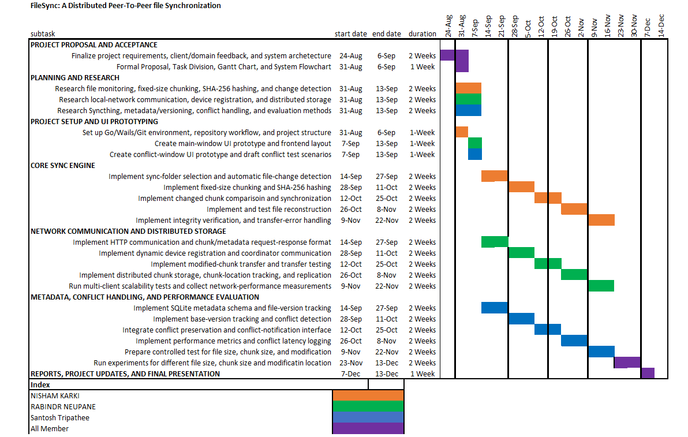

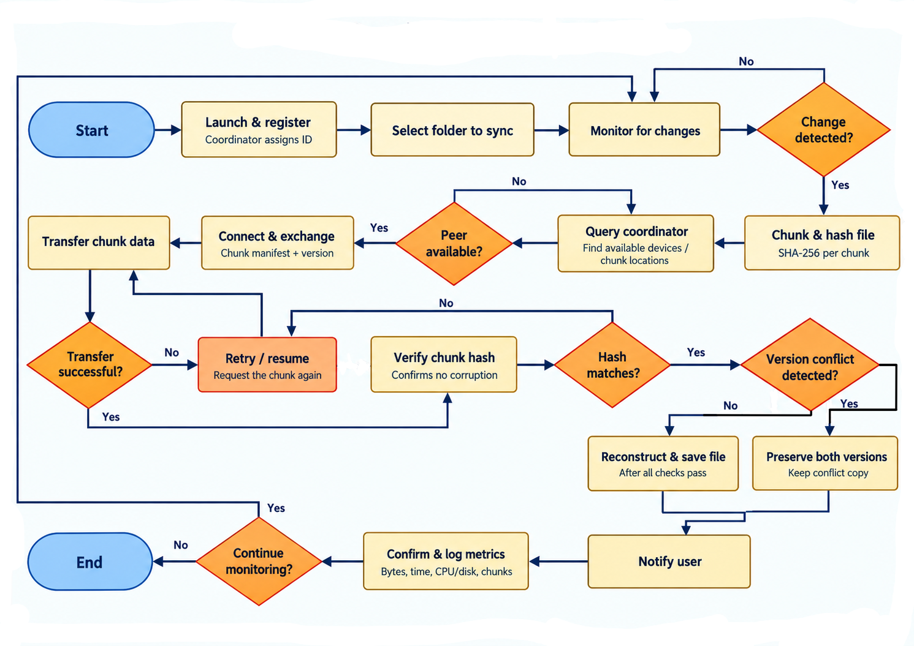
FileSync FlowchART

